TABLE OF CONTENTS:
1) PROCESS NAME AND OWNER 3
A) DOCUMENT ISSUE / STATUS 3
2) PROCESS OVERVIEW 4
3) PROCESS OBJECTIVES 4
4) ASSUMPTIONS 4
A) ACRONYMS 5
5) KPI 5
6) PROCESS DOCUMENTS 5
7) PROCESS MAP 6
8) PROCESS ACTIVITY DETAIL 7
9) PROCESS SIGN OFF 14

PROCESS NAME AND OWNER

a) DOCUMENT ISSUE / STATUS

PROCESS OVERVIEW

A xxx buyer will raise a purchase order which contains componentry parts of a product that xxx directly assembles in the warehouse to cultivate a finished product to sell publicly, i.e. Packaging, labeling and contents. The supplier will distribute the products and provide a PDF invoice, with the order details. The invoice is then processed through Cleardox and imported into Sage to await processing by the Accounts Payable Associate.

Once the products have been receipted by the warehouse, the Purchase Order details will be added to Sage to await matching to the related invoice.

The Accounts Payable Associate will then process the invoice and confirm the quantity and price per unit matches what has been provided on the invoice.

PROCESS OBJECTIVES

The objective of this process is to document the ‘as is’ process for manufacturing PO’s, ensuring invoices are matched to the correct PO for tracking purposes.

ASSUMPTIONS

- Users have access to the following systems: Sage, Procure, Outlook, Cleardox and SuperSet.
- Users have been fully trained on the end-to-end process.
- Users can identify the assigned PO.

a) ACRONYMS

No. | Acronym | Description
1 | AP | Accounts Payable
2 | PO | Purchase Order
3 | FFP | Freight fulfilment & Packaging
4 | INV | Invoice
5 | CD | Clear Data
6 | QEP | Query Error Price
7 | IEP | Internal Error Price
8 | SEP | Supplier Error Price
9 | CNV | Credit Note
10 | KPI | Key Performance Indicator

KPI
Average cost per invoice calculated monthly and reported within the Group SSC KPI Pack.

PROCESS DOCUMENTS

PROCESS MAP

Manifacturing PO Invoices
Phase
Accounts Payable |   .  1  Review  Unposted  Invoices report  START  2.  Download  Invoice from  CD  3.  Search for  invoice in Sage  4.  Sense check  invoice details  5.  Match  receipted stock  to invoice  6.  Sense check  Lines detail  Price Match?  To confirm?  7.  Post  YES  NO  YES  NO  Higher or Lower  Price?  A.  6  Add misc line  -  Product = LEP  LOWER  ?  <20  HIGHER  B.  6  Add misc line  -  Product = TOL  NO  6  C.  Add misc line  Product = QEP  C.  Query with the  buyer  YES  C.  Update Product  to IEP or SEP |   END

PROCESS ACTIVITY DETAIL

Start: A supplier will provide a product that requires payment within the agreed payment terms. An invoice will be produced by the supplier and emailed to the designated shared mailbox. A rule created within the shared mailbox will identify emails with an invoice attachment and automatically forward them onto (email addresst removed) to process via Cleardox the Accounts Payable Associates to validate.

- Log into Superset via Okta, to review the Unposted Invoices report. (Sign in using your windows log in)

Go into <Dashboards> and select ‘Unposted Invoices – Direct.’ Note: Click the star button to add this report to your favorites.

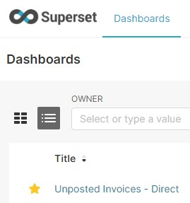

Click the link at the bottom of the page to direct you to the report and export into Excel.

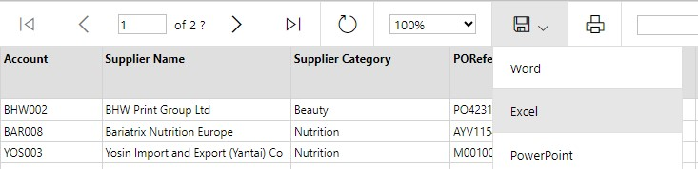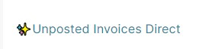

Open the report, filter the supplier category on ‘Group Stock’ and in the PO Reference, filter on the PO’s beginning with ‘M0’.
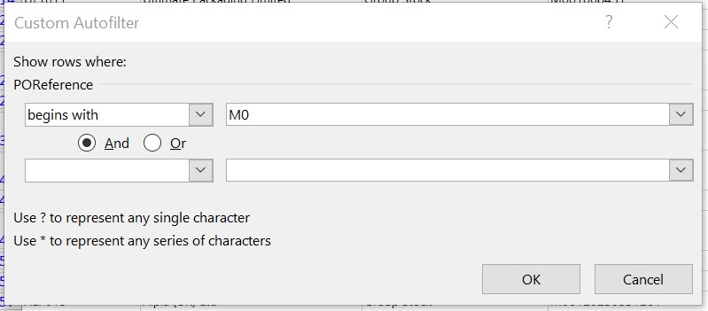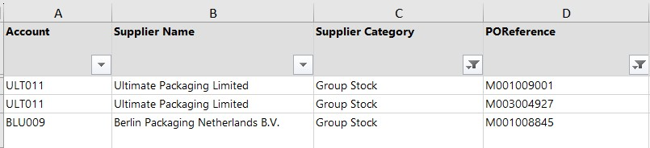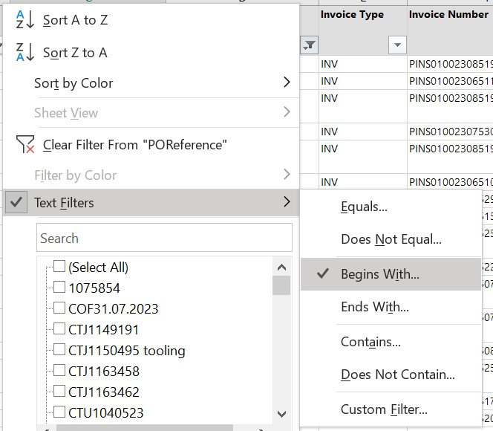

- Take a copy of the first available invoice number and log into Cleardox using the link below.
Log in - Cleardox Suite
Note: to request access to Cleardox, raise a ticket with FSSC Systems SDP - Request Access to Cleardox
Paste the invoice number or PINS Reference into the search bar and right click on the document to bring up the additional details.
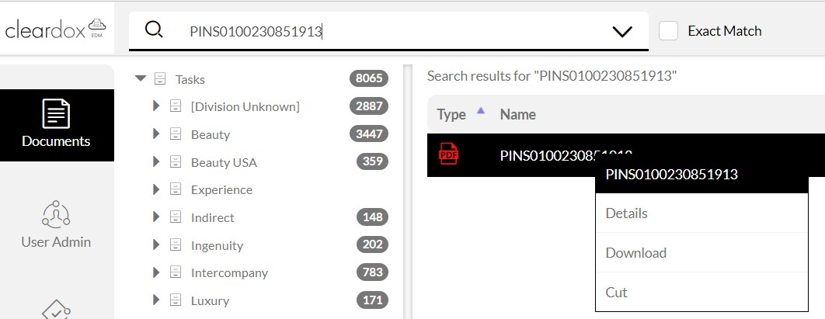

This will then provide you with the option to download the attachment. If the invoice is not found in Cleardox, continue to step 3 as the invoice may have already been attached in Sage. Alternatively, you can search for the invoice in the designated shared mailbox or on the SharePoint location for Finance Documents.
Xxx-FinanceDocumentStorage

- Log into Sage to search for the invoice detail navigating to Purchasing>Invoices>Invoices>All Full Entry
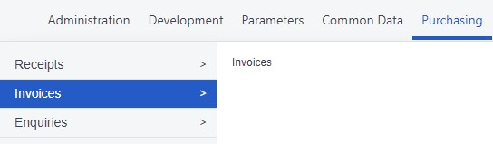

Search the invoice number in the ‘Supplier Document’ field to bring up the invoice details.

- Open the PDF Invoice and sense check the following invoice details against what has been entered within Sage. Amend the ‘Account Date’ to today’s date or at the end of the month before the ledger has been closed - change to the last day of the previous month.

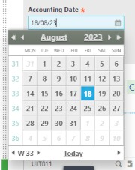
  - BP
  - Site
  - Invoice number
  - Invoice date
  - PO number
  - Value & Currency

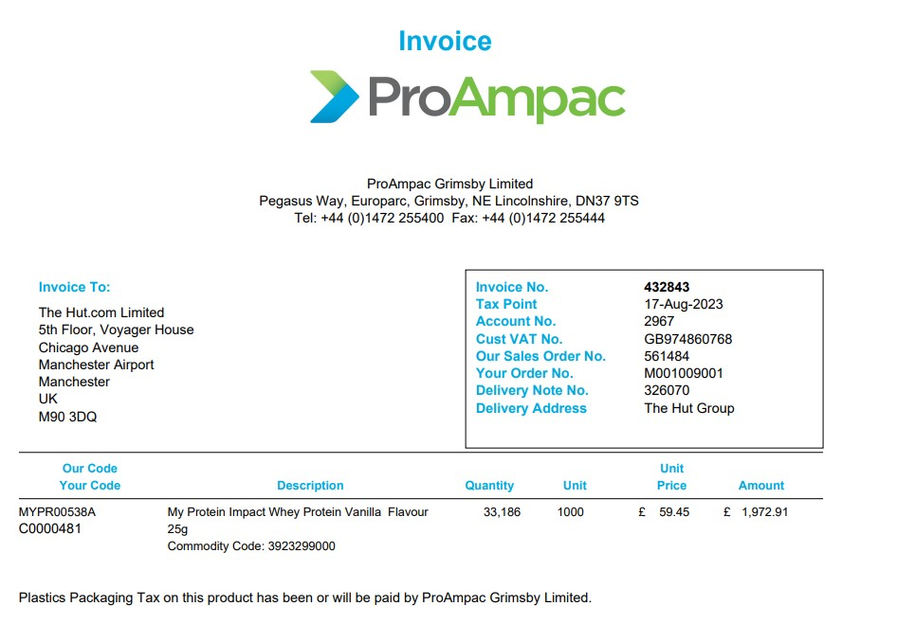

- Match the correct stock to the invoice by selecting ‘Selection Criteria’ and entering the order number in the ‘Manufacturing Order No’ field.
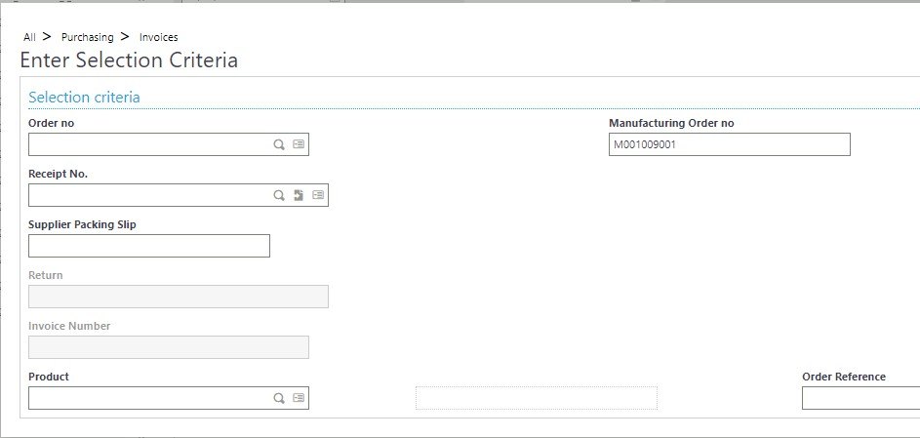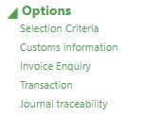

Click the arrow icon to release stock relating to the purchase order. Select the desired lines relating to the invoice, this will automatically fill in the lines tab with the stock selected.

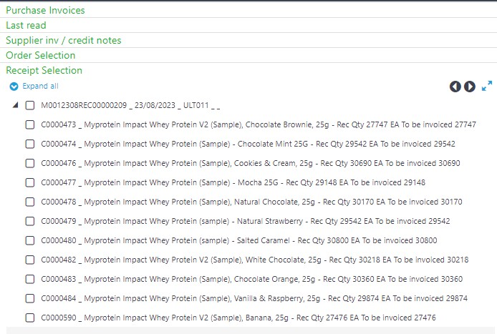

- Sense check the <lines> detail, ensuring the price and quantity match the invoice. If there are any discrepancies, add a new miscellaneous Line.
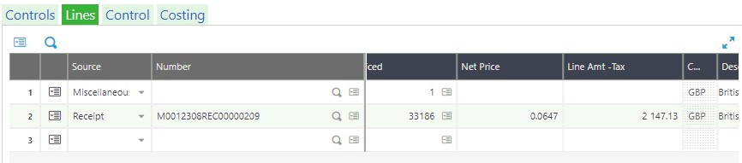

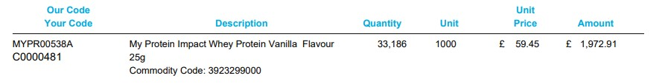

- If the invoice price is lower than the PO price, add a new line by clicking into the data box and selecting ‘Popup view.’

  - Source: Miscellaneous.
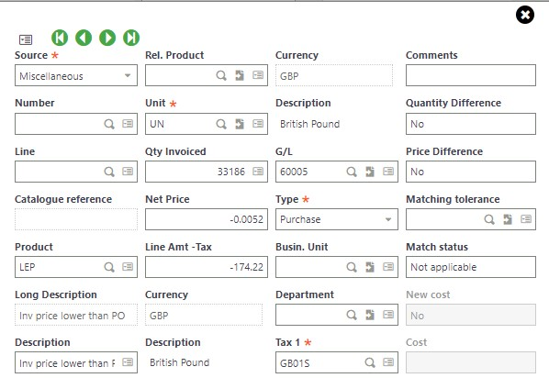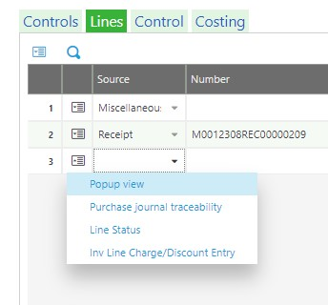
•

Product: LEP
.

•

Qty: From invoice
.

•

Net Price: Calculate the difference
in price.

•

(0.05945

-

0.0647 = 0.0052)

- If the invoice price is higher than the PO by £20 or less, repeat the same process as shown in step a. and change the ‘Product’ to TOL as this does not require any approval.

- If the invoice price is higher than the PO by £20 or more, amend the ‘Product’ to QEP and query the discrepancy with the Buyer to confirm if there has been an internal or external error.

  - If an internal error is identified, amend the ‘Product’ to IEP.
  - If an external error is identified, amend the ‘Product’ to SEP. The Buyer will be responsible for requesting a credit note for the difference in value.

7. Go back into the <Controls> tab and check the invoice status is ‘To Confirm’ before clicking ‘Post’.

If the invoice status is ‘Suspended,’ this means the lines do not match up to the invoice value and will require updating.

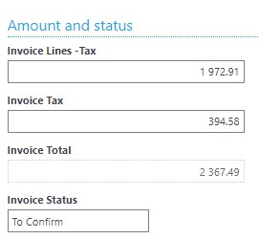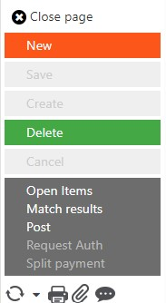

END OF PROCESS

